Application Form for affiliation to the British Schools Gymnastic Association(BSGA)
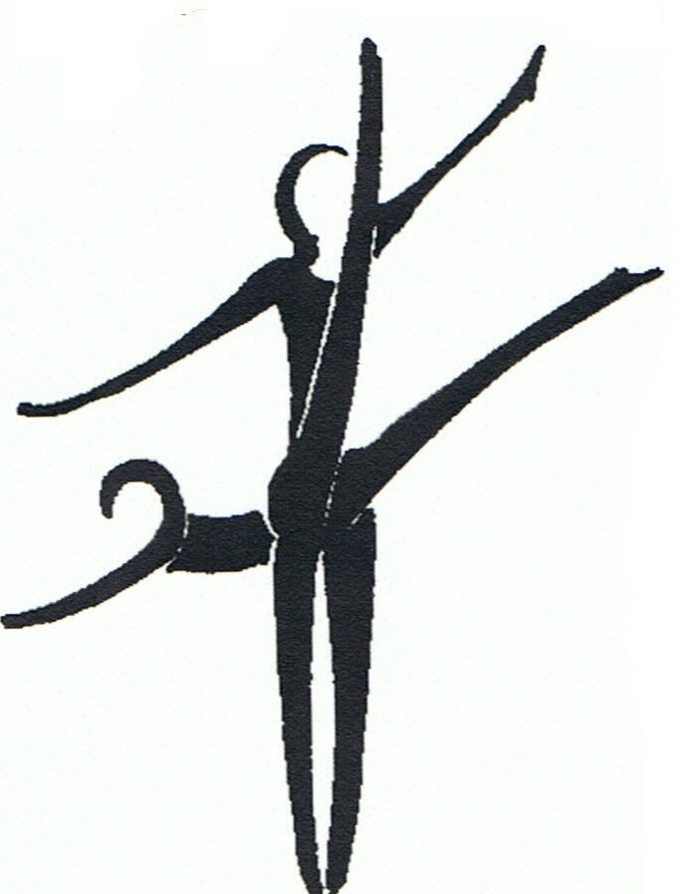

Individual Affiliation -£6

Name of Individual ___________________________________
School ____________________________________________
Address ____________________________________________
Postcode _______________ Tel. No. ____________________
Name of Contact (Print) ________________________________
Relationship of Contact ________________________________
Tel. No. of Contact ____________________
Email Address of Contact________________________________
Signed (contact)___________________ Date ____________
Signed School Representative ______ ____________________
Designation – eg HeadTeacher /Head of PE___________________
Cheque Enclosed £6

Schools Affiliation :- High Schools -£18 Primary Schools -£12

School ___________________________________________
Address ____________________________________________
Postcode _______________ Tel. No. ____________________
Name of Contact (Print) ________________________________
Tel. No. of Contact ____________________
Email Address of Contact________________________________
Designation – eg HeadTeacher /Head of PE___________________
Cheque Enclosed £12/£18

Cheques to be made out to BSGA(NW) and sent to

Mr D Nightingale, 71 Seaford Rd., Bradshaw, Bolton, BL2 4BU

Affiliate as an individual or a school and fill in the appropriate section of the form. Individuals need to give details of school and get a school representative to sign the form.

Cheques made payable to BSGA North West and sent to
Mr J D Nightingale, 71 Seaford Rd., Bradshaw, Bolton, BL2 4BU

