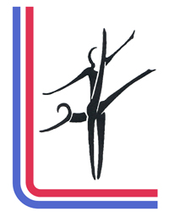BRITISH SCHOOLS GYMNASTICS ASSOCIATION
President: Howard Todd 184 Dalston Road Carlisle Cumbria CA2 6DY
Chair: Jamie Weller 14 Olivier Drive wainscot Rochester Kent ME3 8GQ
Secretary: Annette. Brown 5 Bulrush Close, Llaneirwg, Caerdydd CF3 0AZ
Treasurer: Kathy Jefferies 7 St Anthony Road Heath Cardiff CF14 4DF

BRITISH SCHOOLS GYMNASTICS ASSOCIATION
ANNUAL GENERAL MEETING

Saturday 12th December
Via Zoom

Agenda
- Welcome Chair
- Apologies Chair
- 2019 Minutes Chair

- Matters arising

- Annual Reports:
a Chairs Report JW
b Secretary Report AB
c Treasurers Report KJ
d BSGA Discipline Reports RL, RH, VS, PD,JWo
e Regional Reports

- Election of Officers:
Chair
Vice Chair
Gen Secretary
Treasurer

7. Election of General Committee:
(a) Home nation representatives -England, N. Ireland Scotland, Wales (Exec.)
(b)Discipline Representatives - Rhythmic, Milano Team, Floor & Vault, Acrobatics & Tumbling, Trampoline, Disabilities.
(c) Judging Co-ordinator
(d) Welfare Officer
(e) Media Officer

8. Appointment of auditors

9. Notices of motion (to be received one week before the meeting)

10. National competition dates 2021-2022
AGM 2021 date

It would help if reports could be written as well as presented verbally. If you e mail your report to me I will get copies printed for the meeting. PLEASE let me know if you or your representative will be able to join on the 12th December 2020
Email anniewbrown123@gmail.com 07970077303

